Project Details
Location: 1912 S. Ridgewood Ave
South Daytona FL 32119

Project Size: 1.78 Acres approx.

Project Details: > 15 Units per Acre, plus potential for 50% density Bonus with “Development Incentives”
> 26 Units; 39 with Development Incentive Bonus (See City Codes)

Price: $278,000
Price per unit: $10,700; $7200
Current Zoning: Mixed Use 1
Zoning Change: Small Scale Planned Unit Development; otherwise currently zoned highest and best use.

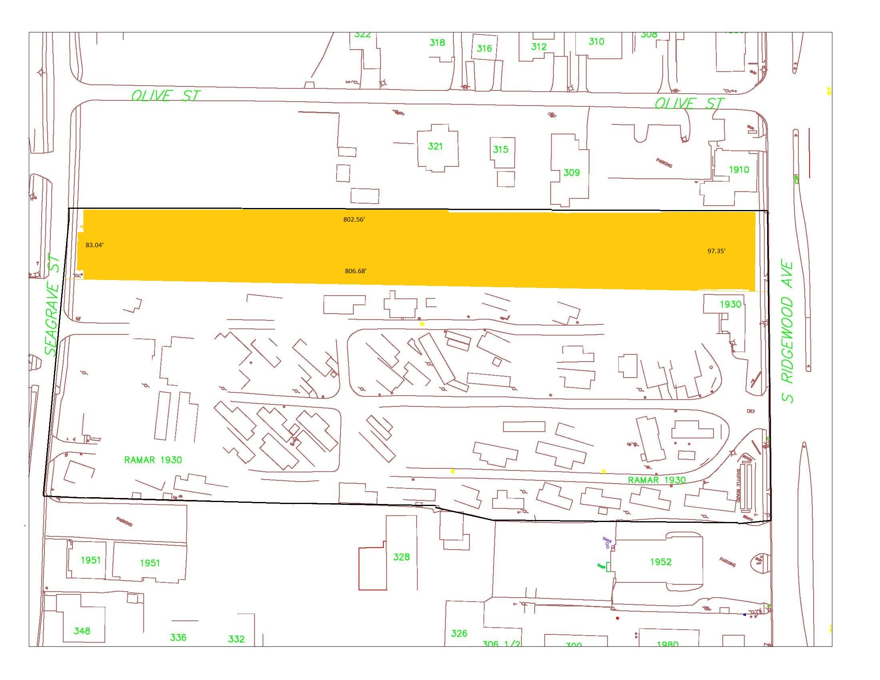
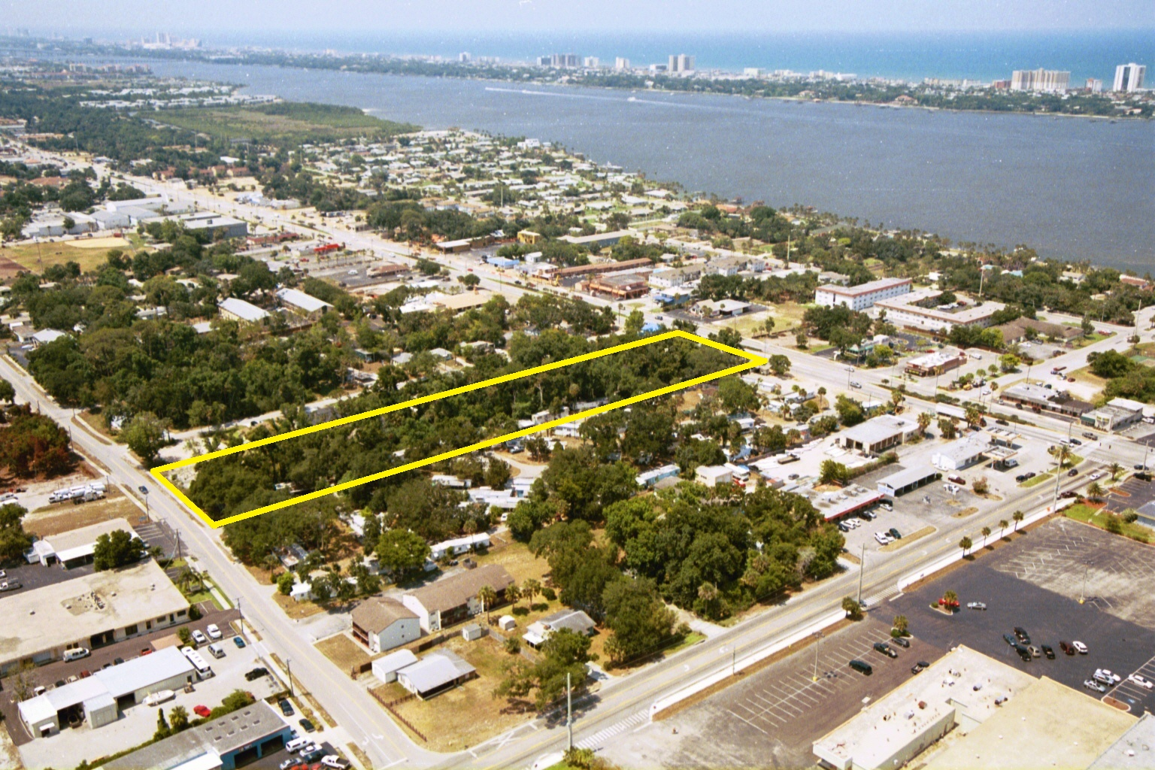

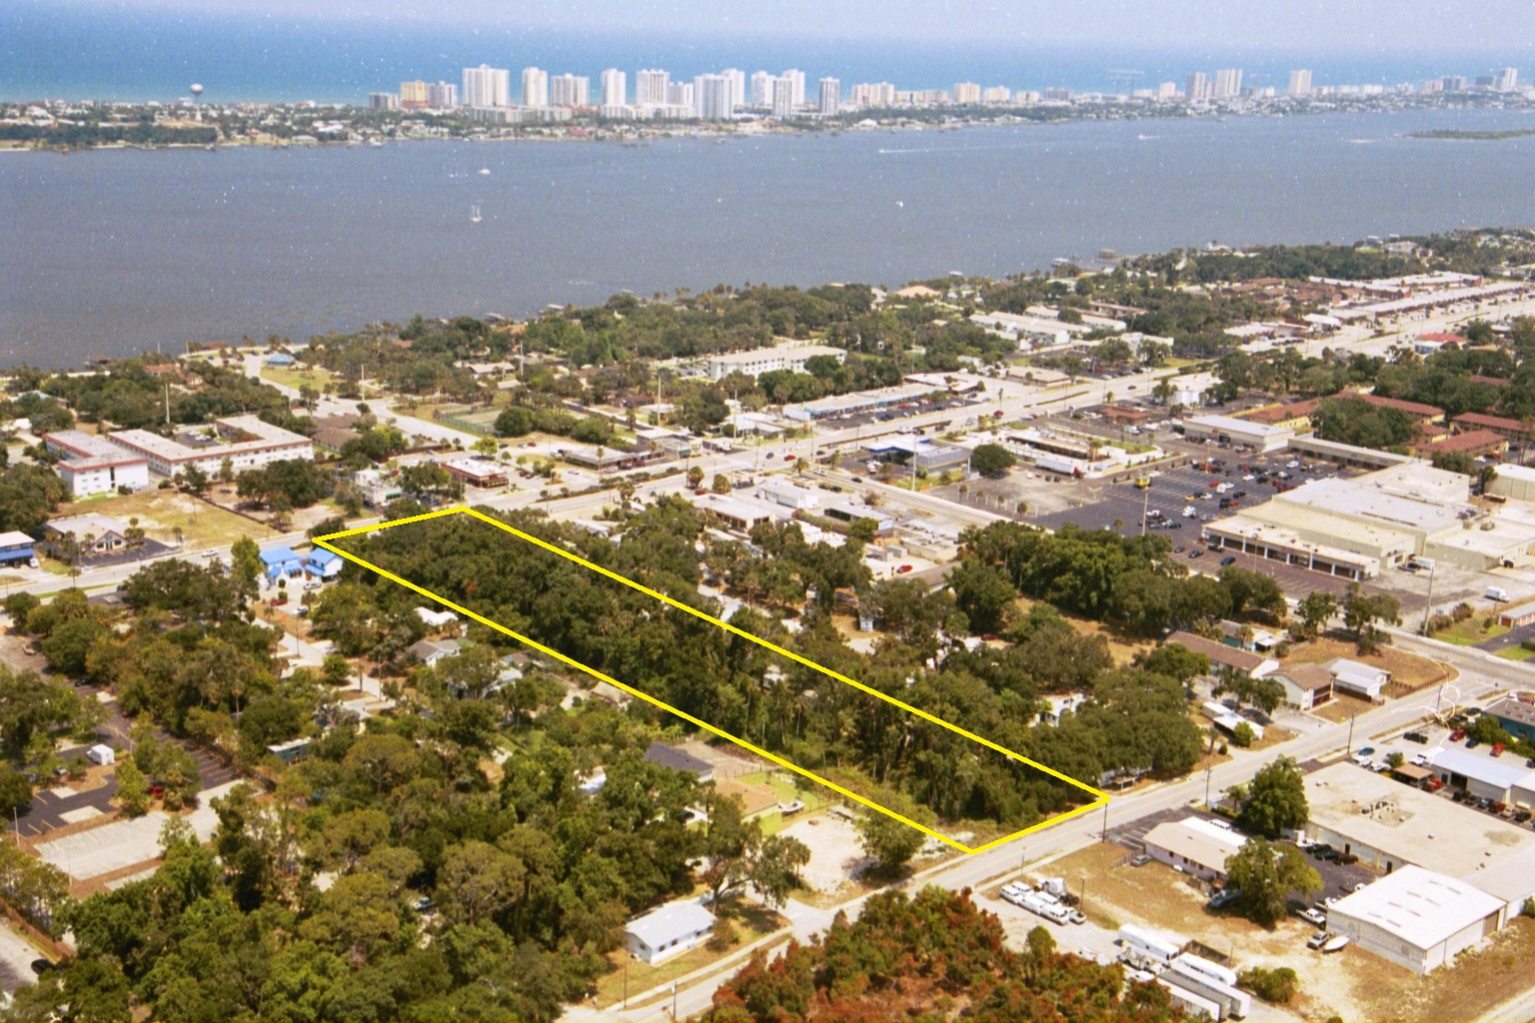

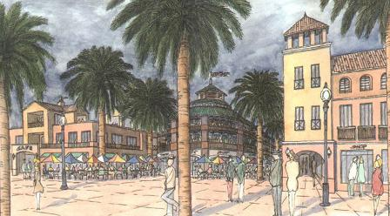



NEW URBANISM promotes the creation and restoration of diverse, walkable, compact, vibrant, mixed-use communities composed of the same components as conventional development, but assembled in a more integrated fashion, in the form of complete communities. These contain housing, work places, shops, entertainment, schools, parks, and civic facilities essential to the daily lives of the residents, all within easy walking distance of each other. New Urbanism promotes the increased use of trains and light rail, instead of more highways and roads. Urban living is rapidly becoming the new hip and modern way to live for people of all ages. Currently, there are over 500 New Urbanism projects planned or under construction in the United States.

NEW URBANISM is the most important planning movement this century, and is about creating a better future for us all. It is an international movement to reform the design of the built environment, and is about raising our quality of life and standard of living by creating better places to live. New Urbanism is the revival of our lost art of place-making, and is essentially a re-ordering of the built environment into the form of complete cities, towns, villages, and neighborhoods - the way communities have been built for centuries around the world. New Urbanism involves fixing and infilling cities, as well as the creation of compact new towns and villages.

THE PRINCIPLES OF NEW URBANISM
The principles of New Urbanism can be applied increasingly to projects at the full range of scales from a single building to an entire community.
1. Walkability
-Most things within a 10-minute walk of home and work
-Pedestrian friendly street design (buildings close to street; porches, windows & doors; tree-lined streets; on street parking; hidden parking lots; garages in rear lane; narrow, slow speed streets)
-Pedestrian streets free of cars in special cases
2. Connectivity
-Interconnected street grid network disperses traffic & eases walking
-A hierarchy of narrow streets, boulevards, and alleys
-High quality pedestrian network and public realm makes walking pleasurable
3. Mixed-Use & Diversity
-A mix of shops, offices, apartments, and homes on site. Mixed-use within neighborhoods, within blocks, and within buildings
-Diversity of people - of ages, classes, cultures, and races
4. Mixed Housing
A range of types, sizes and prices in closer proximity
5. Quality Architecture & Urban Design
Emphasis on beauty, aesthetics, human comfort, and creating a sense of place; Special placement of civic uses and sites within community. Human scale architecture & beautiful surroundings nourish the human spirit
6. Traditional Neighborhood Structure
-Discernable center and edge
-Public space at center
-Importance of quality public realm; public open space designed as civic art
-Contains a range of uses and densities within 10-minute walk
-Transect planning: Highest densities at town center; progressively less dense towards the edge. The transect is an analytical system that conceptualizes mutually reinforcing elements, creating a series of specific natural habitats and/or urban lifestyle settings. The Transect integrates environmental methodology for habitat assessment with zoning methodology for community design. The professional boundary between the natural and man-made disappears, enabling environmentalists to asses the design of the human habitat and the urbanists to support the viability of nature. This urban-to-rural transect hierarchy has appropriate building and street types for each area along the continuum.

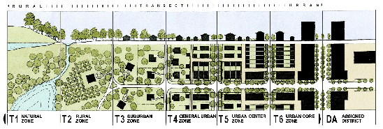
The Transect

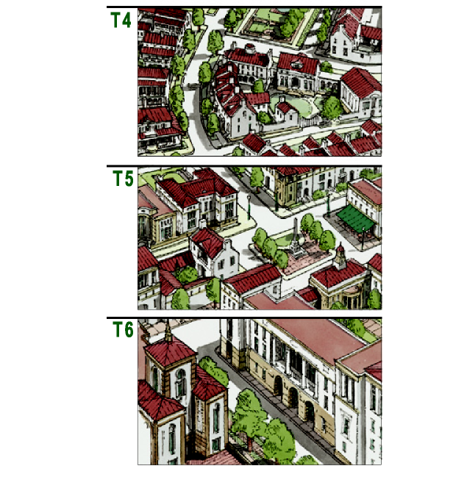
Proposed Transect for 1912 Development Project

Sections T4 to T6

7. Increased Density
-More buildings, residences, shops, and services closer together for ease of walking, to enable a more efficient use of services and resources, and to create a more convenient, enjoyable place to live.
-New Urbanism design principles are applied at the full range of densities from small towns, to large cities
8. Smart Transportation
-A network of high-quality trains connecting cities, towns, and neighborhoods together
-Pedestrian-friendly design that encourages a greater use of bicycles, rollerblades, scooters, and walking as daily transportation
9. Sustainability
-Minimal environmental impact of development and its operations
-Eco-friendly technologies, respect for ecology and value of natural systems
-Energy efficiency
-Less use of finite fuels
-More local production
-More walking, less driving
10. Quality of Life
Taken together these add up to a high quality of life well worth living, and create places that enrich, uplift, and inspire the human spirit.

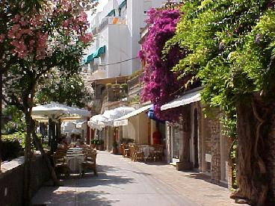

BENEFITS OF NEW URBANISM
1. BENEFITS TO RESIDENTS
Higher quality of life; Better places to live, work, & play; Higher, more stable property values; Less traffic congestion & less driving; Healthier lifestyle with more walking, and less stress; Close proximity to main street retail & services; Close proximity to bike trails, parks, and nature; Pedestrian friendly communities offer more opportunities to get to know others in the neighborhood and town, resulting in meaningful relationships with more people, and a friendlier town; More freedom and independence to children, elderly, and the poor in being able to get to jobs, recreation, and services without the need for a car or someone to drive them; Great savings to residents and school boards in reduced busing costs from children being able to walk or bicycle to neighborhood schools; More diversity and smaller, unique shops and services with local owners who are involved in community; Big savings by driving less, and owning less cars; Less ugly, congested sprawl to deal with daily; Better sense of place and community identity with more unique architecture; More open space to enjoy that will remain open space; More efficient use of tax money with less spent on spread out utilities and roads
2. BENEFITS TO BUSINESSES
Increased sales due to more foot traffic & people spending less on cars and gas; More profits due to spending less on advertising and large signs; Better lifestyle by living above shop in live-work units - saves the stressful & costly commute; Economies of scale in marketing due to close proximity and cooperation with other local businesses; Smaller spaces promote small local business incubation; Lower rents due to smaller spaces & smaller parking lots; Healthier lifestyle due to more walking and being near healthier restaurants; More community involvement from being part of community and knowing residents
3. BENEFITS TO DEVELOPERS
More income potential from higher density mixed-use projects due to more leasable square footage, more sales per square foot, and higher property values and selling prices; Faster approvals in communities that have adopted smart growth principles resulting in cost / time savings; Cost savings in parking facilities in mixed-use properties due to sharing of spaces throughout the day and night, resulting in less duplication in providing parking; Less need for parking facilities due to mix of residences and commercial uses within walking distance of each other; Less impact on roads / traffic, which can result in lower impact fees; Lower cost of utilities due to compact nature of New Urbanism design; Greater acceptance by the public and less resistance from NIMBYS; Faster sell out due to greater acceptance by consumers from a wider product range resulting in wider market share
4. BENEFITS TO MUNICIPALITIES
Stable, appreciating tax base; Less spent per capita on infrastructure and utilities than typical suburban development due to compact, high-density nature of projects; Increased tax base due to more buildings packed into a tighter area; Less traffic congestion due to walkability of design; Less crime and less spent on policing due to the presence of more people day and night; Less resistance from community; Better overall community image and sense of place; Less incentive to sprawl when urban core area is desirable; Easy to install transit where it's not, and improve it where it is; Greater civic involvement of population leads to better governance
OBSTACLES TO OVERCOME
The most important obstacle to overcome is the restrictive and incorrect zoning codes currently in force in most municipalities. Current codes do not allow New Urbanism to be built, but do allow sprawl. Adopting a TND ordinance and/or a system of 'smart codes' allows New Urbanism to be built easily without having to rewrite existing codes.
An equally important obstacle is the continuous road building and expansion taking place in every community across America. This encourages more driving and more sprawl which has a domino effect increasing traffic congestion across the region. Halting road projects and building new train systems helps reverse this problematic trend.

